**1 Introduction**

Vital sign monitoring has become hot research topic in the fields of consumer electronics, biomedical applications, and through-wall detections. In these application scenarios, mainstream solutions include contact-based sensors, camera-based solutions, and microwave radar systems.

For contact-based sensor, its advantages and disadvantages come from its own characteristics: it needs to be in contact to take effect. Therefore, wearing for a long time or requiring frequent contact will bring uncomfortable feeling to the user, which greatly reducing the convenience of the sensors. For camera-based solution, its advantage is that it has a wide range of uses, and tracking and detecting objects is more intuitive. But it also has disadvantages: 1) It is extremely dependent on light. When the light conditions are not good or there is interference from other light sources, the imaging ability drops rapidly. 2) It cannot penetrate objects. When there is an obstacle between the camera and the target, the camera-based solution is completely ineffective. 3) Most camera-based solutions can only provide two-dimensional image information. Even if some cameras can provide depth information [1][2], there is still no method that can better distinguish between people and other static objects.

Compared with conventional contact-based sensors and camera-based solutions, microwave radar systems have their own natural advantages. First, the microwave radar system is a contactless solution and therefore has good convenience in use. Second, microwave radar systems do not depend on light and can penetrate obstacles well [3]-[5]. More importantly, radar sensors are more sensitive to small movements. Based on Doppler and micro-Doppler characteristics, radar sensors can obtain very small movements of target objects such as human respiration and heartbeat [6]-[9].

Continuous-wave (CW) radar has the advantages of low transmit power, high sensitivity and simple structure. Therefore, it is widely used in various fields. Typically, CW radars are divided into two categories: 1) unmodulated CW systems and 2) modulated CW solutions. A typical example of an unmodulated continuous wave system is an interferometer (Doppler) radar [10][11], which operates on a single-tone CW to obtain the target's phase history. In addition, this kind of radar has high accuracy in displacement and velocity measurement [4][6][12]. However, it is difficult for CW radar to obtain the absolute range information of the target. Modulated continuous wave radar includes frequency shift keyed radar [13], stepped frequency continuous wave radar [14] and frequency modulated continuous wave (FMCW) radar [15]-[21]. As one of the most popular types, FMCW radar can easily and accurately obtain the accurate distance information of the target. In addition, if the coherence of the system is achieved, FMCW radar can extract Doppler information related to the radial velocity of the target and measure the displacement of the target. However, the hardware and signal processing of the FMCW system to measure range profile is much more complicated than the hardware and signal processing of the unmodulated CW system. Moreover, the displacement accuracy of the FMCW radar may not be as good as that of the unmodulated CW system, which can easily achieve sub-millimeter accuracy [15]. By making the radar coherent, the phase history of the target can be preserved during the coherent processing interval (CPI), so that Doppler information can be derived, which provides two dimensions: distance and Doppler. This two-dimensional information can help isolate the required moving target from the surrounding static clutter, thereby achieving the detection of vital signals.

**3 FMCW Radar**

**2.1 Composition of FMCW radar system**

The composition of FMCW radar system mainly includes: sawtooth wave signal generator, transceiver module, digital-to-analog converter, digital signal processor and controller. The signal is generated by the sawtooth wave signal generator, passed through the frequency multiplier and the power amplifier in turn, and transmitted by the transmitting antenna. The electromagnetic wave is reflected by the object and received by the receiving antenna. The received signal is mixed with the transmitted signal after passing through a low-noise amplifier to obtain an intermediate frequency signal. Finally, the intermediate frequency signal is filtered and ADC sampled sequentially, and then input to the back end for further signal processing. The block diagram of a typical FMCW radar system is shown in Figure 2.1.

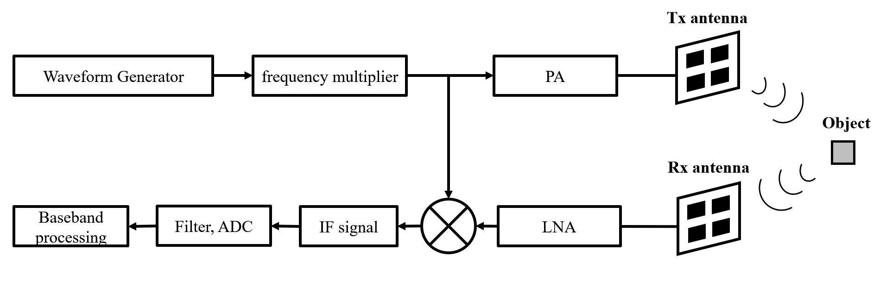

Fig. 2.1. Block diagram of a typical FMCW radar system

**2.2 Analysis of FMCW Radar IF Signal**

For FMCW radar, a variety of modulations is possible. The transmitter frequency can slew up and down as follows: Sine wave, Sawtooth wave, Triangle wave, Square wave, etc.

Sawtooth modulation is the most used in FMCW radars, so the following analysis is based on the sawtooth wave.

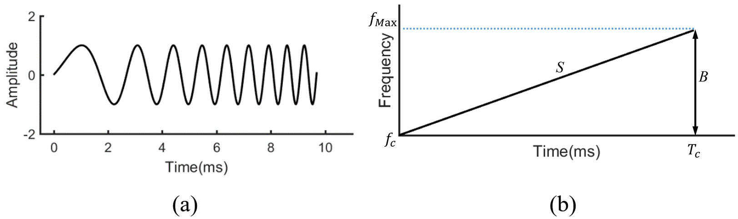

Fig. 2.2. Block diagram of a typical FMCW radar system

The sawtooth wave of FMCW radar is a frequency linear modulation method. The frequency of electromagnetic waves changes linearly with time. The schematic diagram is shown in Figure 2.2. Figure 2.2 (a) shows the time domain representation. The transmitted signal in a cycle is usually called a chirp. Figure 2.2 (b) shows the frequency-time diagram of a chirp.

Denote as the chirp repetition period, is the bandwidth of the chirp, . The mathematical expression for the transmitted signal within one frequency ramp interval is:

|  |  |  |
| --- | --- | --- |
|  |  |  |

where is the center frequency of the frequency ramp, is the initial phase residual, . Suppose that there is a reflection point, and its distance from the radar as a function of time is . Assuming that the movement of the scattering point is relatively slow, thus can be regarded as a constant within a certain period. This is a "stop-and-go" hypothesis, which is extremely common when dealing with slow moving targets. Therefore, for the scattering point located at , the echo signal received by the FMCW radar is a function of the time delay and a certain amplitude attenuation of the transmitted signal. Among them, the time delay is:

|  |  |  |
| --- | --- | --- |
|  |  |  |

Therefore, the echo signal can be expressed as:

According to Figure 2-1, the received signal is mixed with the transmitted signal. After that, the resulting mixed signal is low-pass filtered and the intermediate frequency signal is obtained:

|  |  |  |
| --- | --- | --- |
|  |  |  |

It can be seen from equation (2-4) that the obtained intermediate frequency signal is a sinusoidal motion with frequency :

|  |  |  |
| --- | --- | --- |
|  |  |  |

**2.3 FMCW radar parameter estimation**

Based on the intermediate frequency signal obtained in Section 2.2, parameters such as the position, velocity, and angle of the target object can be estimated. The parameter estimation methods are discussed separately below.

2.3.1 FMCW radar range estimation

Since the frequency of the EM wave emitted by the FMCW radar system changes linearly with time, the frequency of the received EM wave also changes linearly with time. Therefore, when the frequency of the IF signal obtained by mixing the transceiver signals is determined, the distance of the object can be obtained according to the known slope S of the sawtooth wave modulation.

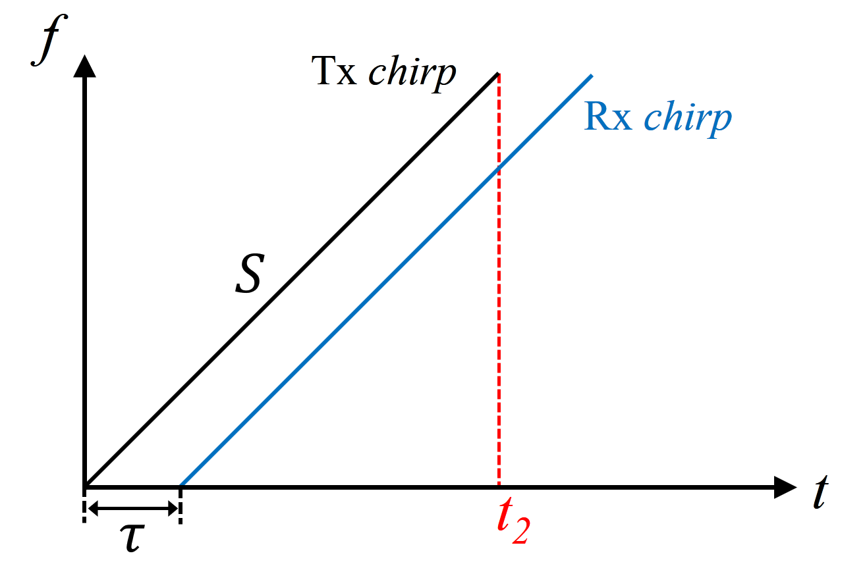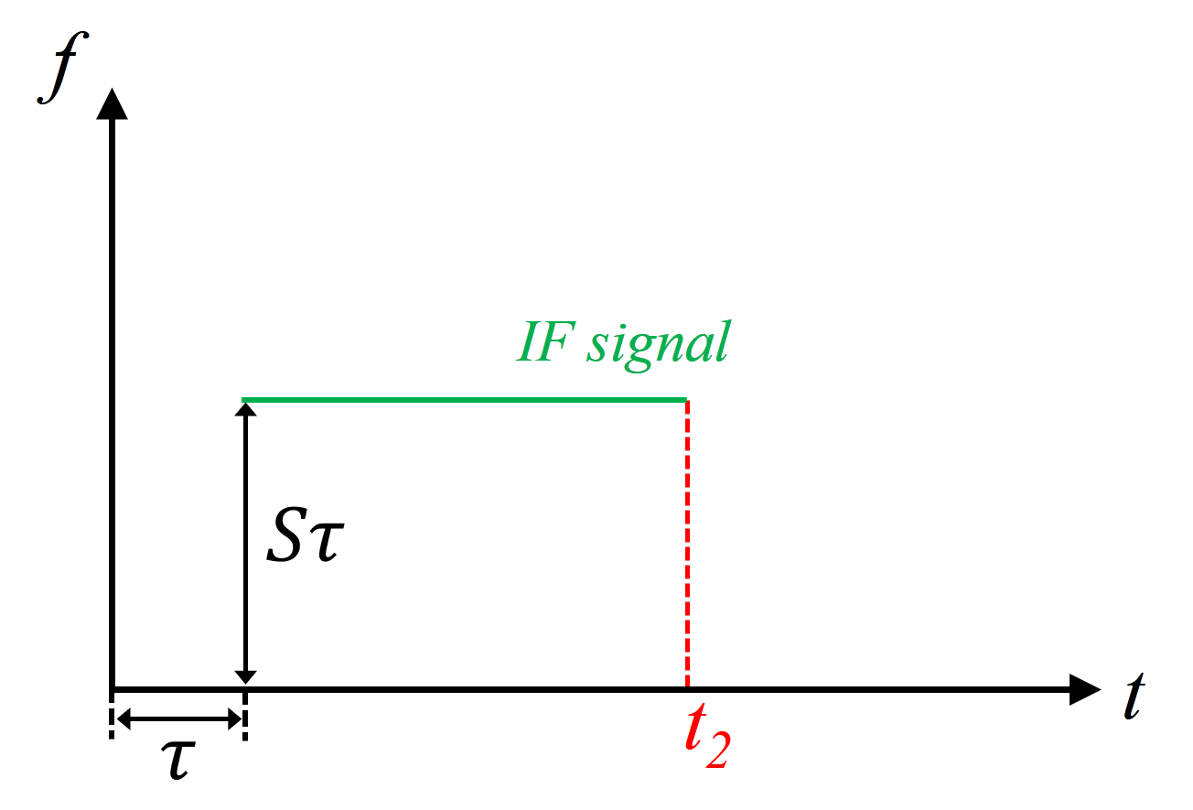

(a) (b)

Fig. 2.3. FMCW intermediate frequency signal diagram

As shown in Figure 2.3, the transmitted signal is received by the radar after time . Therefore, the transmitted Tx chirp and the received Rx chirp are two parallel lines with the same slope on the frequency-time graph. Note that the slope of the transmitted sawtooth wave is S, and the duration of the transmitted signal is . The frequency-time diagram of the IF signal is shown in Figure 2.3 (b). The frequency of the intermediate frequency signal .

Therefore, when there is a single object in front of the radar, the frequency-time diagram of the generated intermediate frequency signal is a single-valued line, and the frequency is proportional to the EM wave propagation time. From formula (2-2), we know that the propagation time is proportional to the distance from the object to the radar, that is , where *d* is the distance from the object to the radar.

In summary, the distance from the object to the radar can be obtained from the frequency of the intermediate frequency signal obtained in equation (2-4):

|  |  |  |
| --- | --- | --- |
|  |  |  |

It should be noted that when using ADC for sampling, the time-point of interest must be within the time window of [, ].

2.3.2 FMCW radar velocity estimation

The FMCW radar speed estimation requires the use of multiple periods of Tx chirp. By extracting the changes of the phase information of multiple chirps, the displacement of the object within the two sawtooth wave periods is obtained, and then the estimation of the object's velocity is completed.

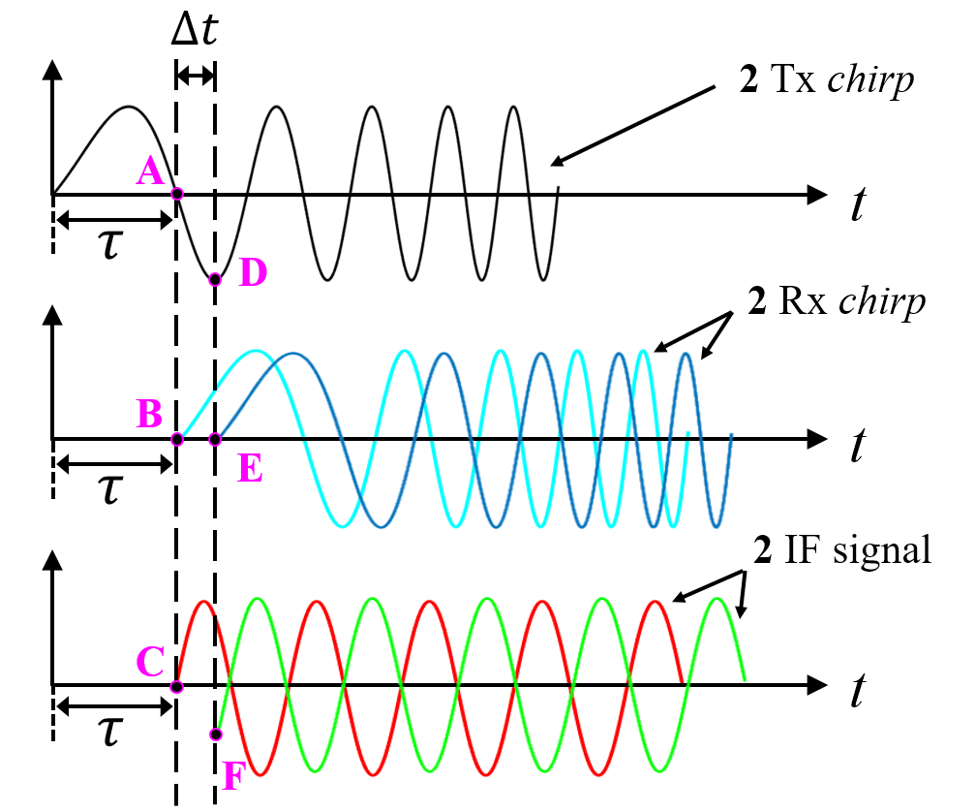

Fig. 2.4. Phase analysis of FMCW radar IF signal

The first step is the phase analysis of the FMCW radar IF signal. The top graph in Figure 2.4 is the time-domain waveform of the transmitted signal. Assuming that two chirps are continuously transmitted, the repetitive time of the transmitted signal waveform is . Since the repetitive time is generally in the μs level, which is very small relative to the time axis, the image of the two consecutive transmitted signal waveforms on the time axis can be considered overlapping. That is, the top image is actually a superimposed image of two transmitted waveforms with very short intervals on the time axis.

Suppose the first Tx chirp emitted returns after time τ, forming the light blue waveform in the middle image in Figure 2.4, and the second Tx chirp returns after time as a dark blue waveform. The delay is caused by a slight displacement of the object within two repetitive periods of emitted Tx signal waves. It should be noted that and are also very small amounts of time, so they are enlarged for display here.

The bottom figure of Figure 2.4 is the IF signal formed by the two received signals and the transmitted signal respectively. By analyzing the phases of the two IF signals, the moving distance of the object during time can be obtained.

It can be obtained from Figure 2.4 that the phase difference between point A and point D is . At the same time, we get the relationship in the waveform: point B and point E are 0 phase, the phase of point C is the negative value of phase A; the phase of point F is the negative value of phase D. Therefore, the phase difference between point A and point D is also the phase difference between point C and point F.

According to the conclusion in section 2.2, the expression of sinusoidal IF signal can be rewritten as follows:

where is the frequency of the signal, c is the speed of light.

When there are two IF signals, the phase difference is:

note, then the velocity estimation is:

Taking the example that have mentioned before. For a FMCW radar operating at 77 GHz, the phase change . It can be concluded that the frequency is almost negligible for small movement changes, but the phase information is very sensitive to small distance changes. Therefore, the phase information is used to complete the velocity estimation with higher resolution.

It should be noted that because the speed is detected using changes in phase information, it must be effective within the range of , which limits the maximum upper limit of speed estimation :

|  |  |  |
| --- | --- | --- |
|  |  |  |

In addition, the direction of the object's movement relative to the radar can be distinguished by the sign of :

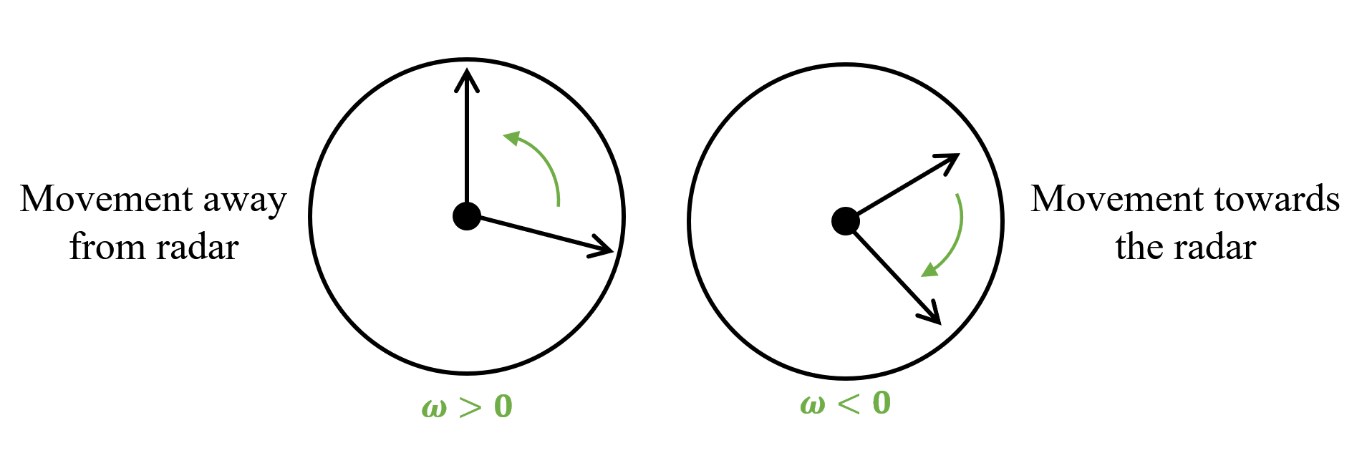

Fig. 2.5. Relationship between phase sign and object movement direction

As shown in Figure 2.5, when , the object moves in the direction away from the radar. When , the object moves in the direction of approaching the radar.

2.3.3 FMCW radar angle estimation

The angle estimation of the FMCW radar requires at least two receiving antennas. The schematic diagram is shown in Figure 2.6.

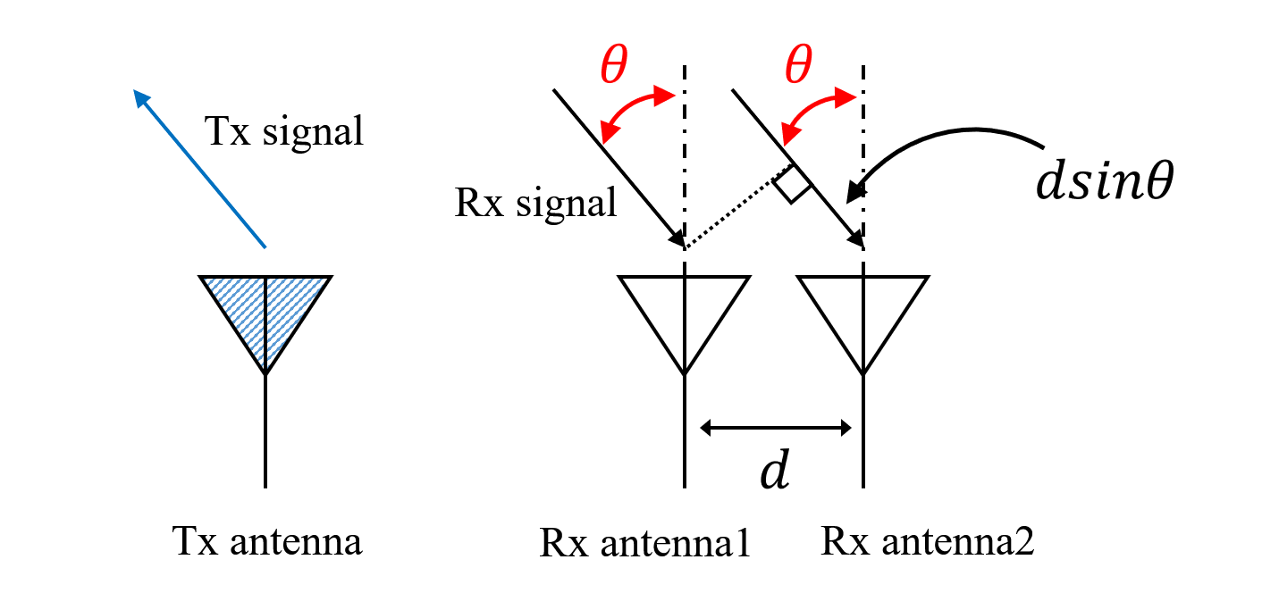

Fig. 2.6. Schematic diagram of FMCW radar angle estimation

Assuming that the distance between the two receiving antennas is *d*, since *d* is relatively small compared to the distance from the object to the radar, the reflected signals reaching the two receiving antennas can be regarded as parallel incidence. Assuming the normal angle between the object and the receiving antenna is , the reflected signals received by the receiving antennas 1 and 2 have a wave path difference . Therefore, the phase difference of the reflected signals received by the two receiving antennas contains the angle information of the target.

The phase difference between Rx antennas can be expressed as:

|  |  |  |
| --- | --- | --- |
|  |  |  |

Inversely transform equation (2-13) to obtain the angle information of the target:

|  |  |  |
| --- | --- | --- |
|  |  |  |

It should be noted that for equation (2-14), this is the first time that nonlinearity occurs in FMCW radar parameter estimation. The non-linearity of the arc sine function makes the sensitivity differs at different angles.

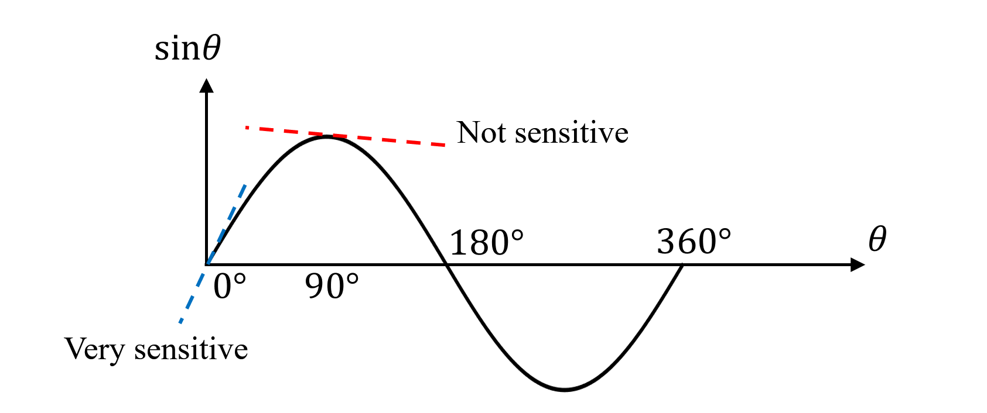

Fig. 2.7. FMCW radar angle estimation sensitivity with angle

As shown in Figure 2.7, when the angle close to 0°, since the slope of the sine function is large, the change of the arc sine function to the angle is obvious, but when it reaches 90°, the slope of the sine function gradually approaches 0, therefore, the accuracy of angle estimation decreases rapidly. That is, when the object is directly in front of the radar, the angle estimation is the most accurate. The closer the target is to the sides of the radar, the worse the angle estimation accuracy will be.

2.3.4 FMCW radar phase-based range-tracking algorithm for vital sign monitoring

Since the displacement of vital signs such as respiration and heartbeat is very small, the phase-based range-tracking algorithm has a better effect on obtaining accurate vital sign detection. If a Fourier transform is performed over each period of the IF signal (2-4), its associated range profile is derived. The IF signal after Fourier transform can be expressed as:

|  |  |  |
| --- | --- | --- |
|  |  | (2-34) |

where . After a simple scaling process of the frequency axis, the corresponding range profile can be extracted.

For an LFMCW radar intended to monitor vital signs, a close look must be given at the exponential factor in (2-34). Denote the phase history in (2-34) as , then the phase history is simply related to the range evolution of the target by

|  |  |  |
| --- | --- | --- |
|  |  | (2-35) |

Hence, a proper range tracking of the target requires the preservation of the phase history. Assume that the signal samples associated with distinct chirp intervals are stacked in rows. This constitutes the raw-data matrix, which is denominated (*n=1, 2, …, N; m=1, 2, …, M*, *N* being the number of transmitted ramps and *M* being the number of samples per chirp). The corresponding signal processing to derive the range evolution is divided into four steps:

Step 1) Perform a fast Fourier transform over each row of the raw-data matrix M[*n, m*]. Denote the resulting range-profile matrix as R[*n, m*]

Step 2) Choose the range bin *m\** in which the target is found. Synthesize the signal s[*n*]=R[*n, m\**], which is a column of the range-profile matrix R[*n, m*].

Step 3) Exact the phase of the signal s[n] and unwarp it. Denote the phase of the signal s[*n*] as .

Step 4) From (2-35), calculate the range estimation as .

**2.4 Examples of FMCW radar on contactless vital sign monitoring**

In recent years, FMCW radar has been widely used in noncontact range tracking of vital signs, e.g., respiration. Next, some examples are given to analyze several typical FMCW radars for vital sign monitoring.

2.4.1 Respiration monitoring

The body surface movements due to physiological motions modulates the phase of the received radar signal and can be further processed to extract the breathing and heart-rate. A deramping-based LFMCW radar scheme has been proposed [15]. The described LFMCW radar architecture is conceptually simple and the deramping process greatly simplifies its hardware implementation mainly in terms of sampling speed for the Rx ADC.

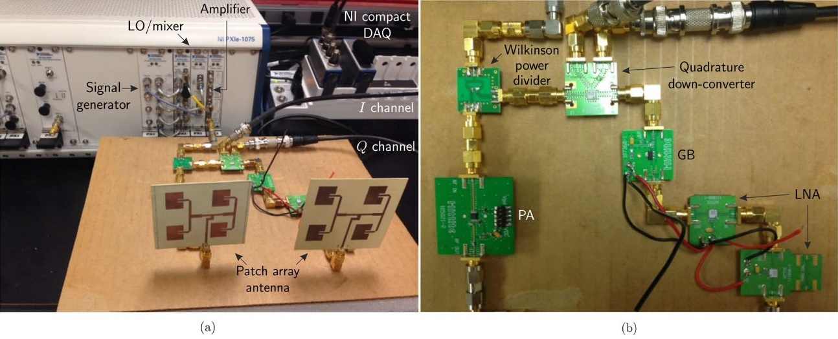

Fig. 2.8. Photograph of the developed LFMCW radar system prototype. (a) Complete view. (b) Detail. [15]

The photograph of the constructed LFMCW radar system is depicted in Fig. 2.8. It consists of Tx, Rx, and signal-acquisition modules. A photograph of the experiment setup for vital-sign sensing from human target is depicted in Fig.2.9.

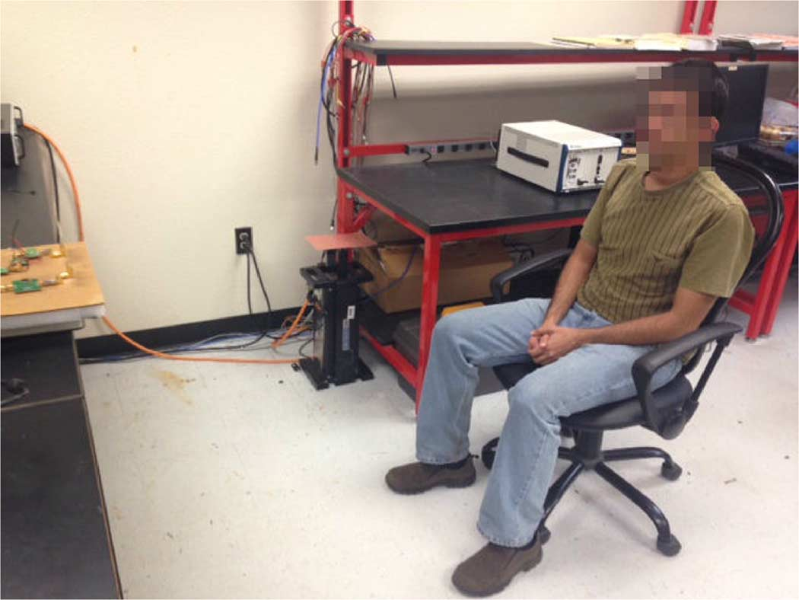

Fig. 2.9. Photograph of the real experimental setup of the human vital-sign

tracking test [15]

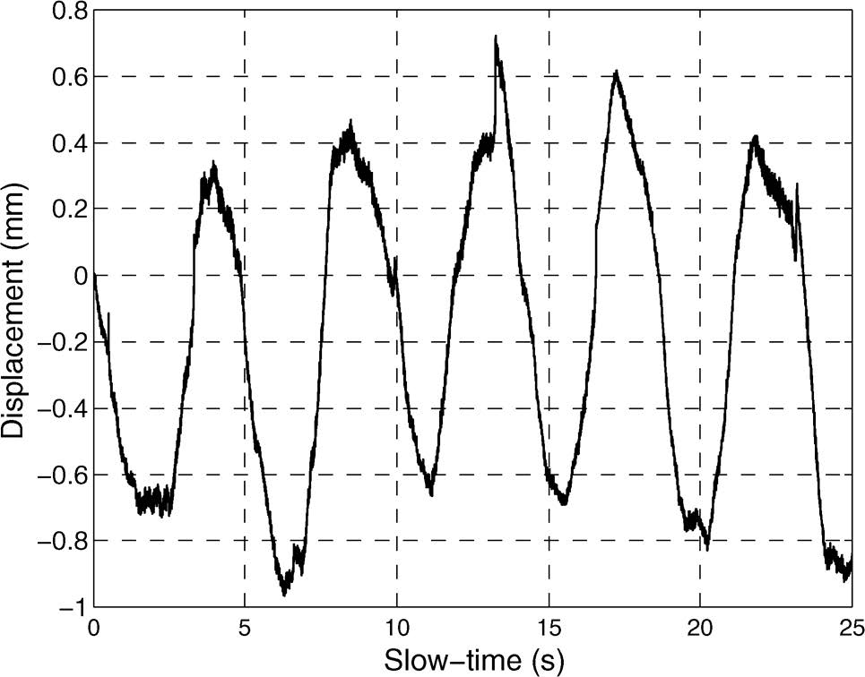

Fig. 2.10. Detected human respiration pattern [15]

By using the phase-based range-tracking algorithm mentioned in 2.3.4, minor movements of the human body can be detected. Fig.2.10 plots the measured human respiration detection result. The respiration rate of the subject was about 13 cycles/min and it is almost coinciding with the data measured by radar.

2.4.2 Indoor human tracking

Radar-based human tracking can be applied to indoor healthcare scenarios, such as fall detection of elderly people. Some portable FMCW radar prototype for indoor human tracking are presented [16][17]. The block diagram of the FMCW radar in [16] is shown in Fig. 2.11.

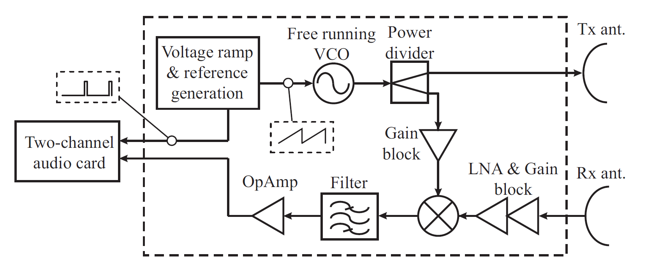

Fig. 2.11. Block diagram of the FMCW radar in [16]

The RX part proceeds with the mixing of a replica of the transmitted signal and the simultaneous sampling of the reference and baseband signals enables a correct formatting of the baseband-signal samples to construct the raw-data matrix, which guarantees the coherence of the system. Therefore, the system can preserve the phase history of targets and videos of inverse synthetic aperture radar (ISAR) images can be reconstructed.

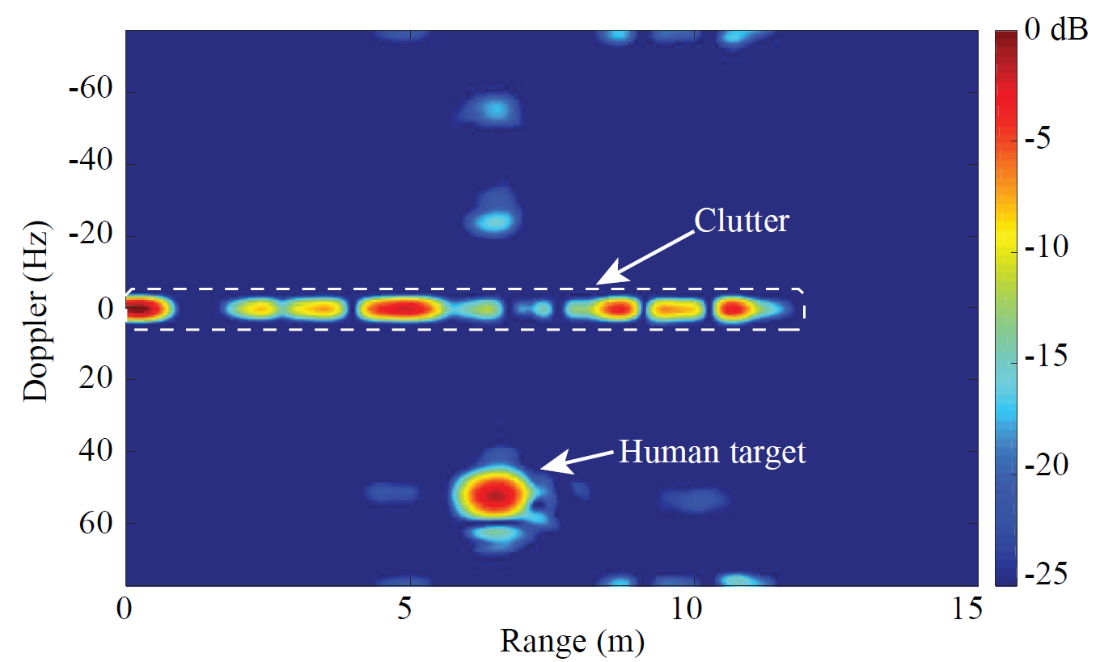

Fig. 2.12. ISAR frame of a human target [17]

Fig. 2.12 shows the range-Doppler frame of the human tracking experiment. The moving human target can be observed in this figure with the person’s Doppler frequency and range and the entire video can clearly complete the tracking of human targets.

2.4.3 Hybrid radar systems for human tracking and identification

Several hybrid radar systems that integrates the FMCW mode and interferometry mode have been published [18][19]. The FMCW mode is responsible for absolute range detection and the interferometry mode takes care of weak physiological movement monitoring.

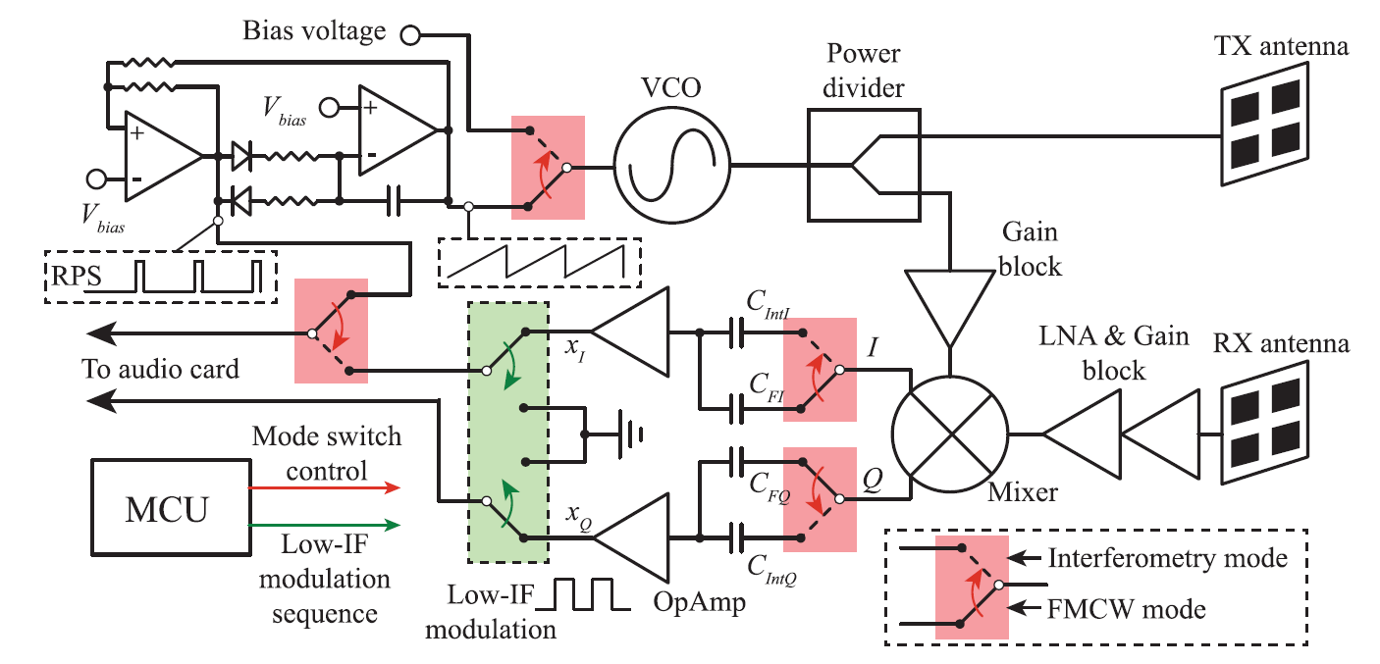

Fig. 2.13. Block diagram of the hybrid radar system in [18]

The block diagram of the FMCW interferometry hybrid radar system in [18] is shown in Fig 2.13. The two different radar modes share most of the RF components and signal paths and analog switches configured by an on-board microcontroller are used to select the operational modes.

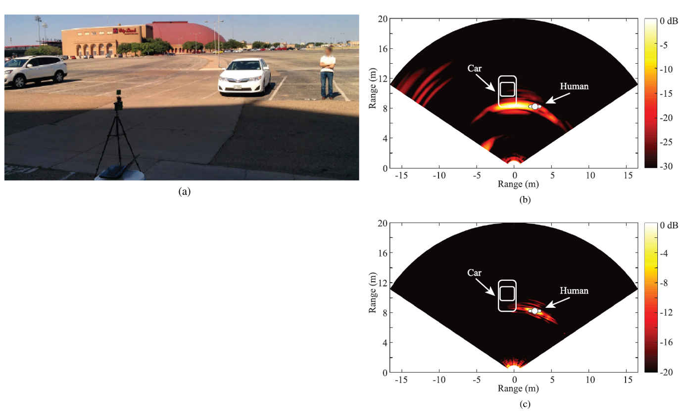

Fig. 2.14. Experimental setup and human target identification result [18]

The experiment setup for stationary target discrimination is shown in Fig.2.14(a). In this experiment, the human subject stood beside a parked car with a running engine. The proposed portable radar was mounted on a tripod to do a mechanical scan in the FMCW mode. Fig. 2.14(b) presents the 2-D mapping of the range profile. Because the frequency of car engine vibration is different from the frequency of human breathing, static objects can be discriminated by measuring images of several frames. Fig 2.14(c) is the 2-D mapping result for human target identification.

2.4.4 Other types of FMCW radar vital signs detection applications

A PCB realization of a K-band portable FMCW radar with beamforming array is presented [20]. It demonstrated an alternative approach to achieve portable and low-cost beamforming array radar systems with vector controllers and a six-port circuit. Range-gating and beamforming techniques allow the signal of interest to be isolated from surrounding clutter [21].

In addition, some companies such as Texas Instruments, Infineon, and Calterah have developed a series of FMCW radar products [22], and these products have greatly contributed to the development of vital sign monitoring using FMCW radars. Fig. 2.15 shows the Infineon’s BGT60TR24B Radar Sensor. It is a short range 60 GHz radar sensor with FMCW and Doppler-interferometric two modes. Fig. 2.16 shows the CALTERAH’s CAL60S244-IB radar sensor. It is a 4T4R 60GHz FMCW Radar with antenna array embedded in the package.

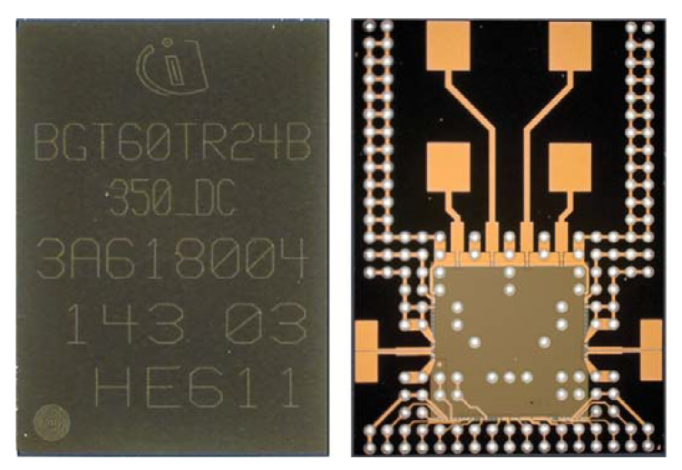

Fig. 2.15. Infineon’s BGT60TR24B Radar Sensor

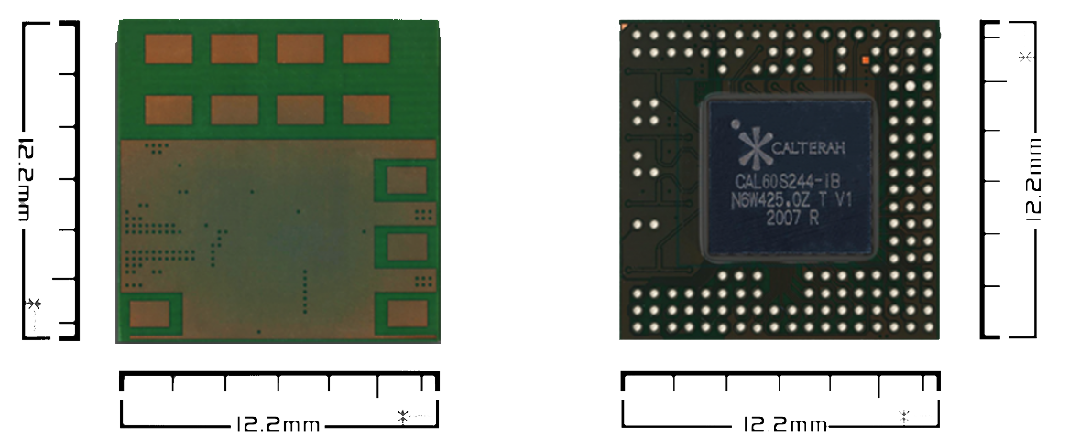

Fig. 2.16. CALTERAH’s CAL60S244-IB 4T4R 60GHz Radar SoC AiP

**Reference**

[1]S. Zhang and P. S. Huang, “High-resolution, real-time three-dimensional shape measurement,” Opt. Eng., vol. 45, no. 12, pp. 123601-1–123601-8, Dec. 2006.

[2]Y. Wang, K. Liu, Q. Hao, D. L. Lau, and L. G. Hassebrook, “Period coded phase shifting strategy for real–time 3-D structured light illumination,” IEEE Trans. Image Process., vol. 20, no. 11, pp. 3001–3013, Nov. 2011.

[3]F.-K.Wang, T.-S. Horng, K.-C. Peng, J.-K. Jau, J.-Y. Li, and C.-C. Chen, “Seeing through walls with a self-injection-locked radar to detect hidden people,” in IEEE MTT-S Int. Microw. Symp. Dig., Jun. 2012, pp. 1–3.

[4]F. K. Wang, T. S. Horng, K. C. Peng, J. K. Jau, J. Y. Li, and C. C. Chen, “Detection of concealed individuals based on their vital signs by using a see-through-wall imaging system with a self-injectionlocked radar,” IEEE Trans. Microw. Theory Techn., vol. 61, no. 1, pp. 696–704, Jan. 2013.

[5]X. Liu, H. Leung, and G. A. Lampropoulos, “Effect of wall parameters on ultra-wideband synthetic aperture through-the-wall radar imaging,” IEEE Trans. Aerosp. Electron. Syst., vol. 48, no. 4, pp. 3435–3449, Oct. 2012.

[6]C. Gu et al., “Accurate respiration measurement using DC-coupled continuous-wave radar sensor for motion-adaptive cancer radiotherapy,” IEEE Trans. Biomed. Eng., vol. 59, no. 11, pp. 3117–3123, Nov. 2012.

[7]Y. Kim and H. Ling, “Through-wall human tracking with multiple Doppler sensors using an artificial neural network,” IEEE Trans. Antennas Propag., vol. 57, no. 7, pp. 2116–2122, Jul. 2009.

[8]H. Gao, L. Xie, S. Wen, and Y. Kuang, “Micro-Doppler signature extraction from ballistic target with micro-motions,” IEEE Trans. Aerosp. Electron. Syst., vol. 46, no. 4, pp. 1969–1982, Oct. 2010.

[9]M. Otero, “Application of a continuous wave radar for human gait recognition,” Proc. SPIE, vol. 5809, pp. 538–548, May 2005.

[10]C. Li, X. Yu, C.-M. Lee, D. Li, L. Ran, and J. Lin, “High-sensitivity software-configurable 5.8-GHz radar sensor receiver chip in 0.13-μm CMOS for noncontact vital sign detection,” IEEE Trans. Microw. Theory Techn., vol. 58, no. 5, pp. 1410–1419, May 2010.

[11]C. Gu, G. Wang, Y. Li, T. Inoue, and C. Li, “A hybrid radar-camera sensing system with phase compensation for random body movement cancellation in Doppler vital sign detection,” IEEE Trans. Microw. Theory Techn., vol. 61, no. 12, pp. 4678–4688, Dec. 2013.

[12]C. Li, J. Ling, J. Li, and J. Lin, “Accurate Doppler radar noncontact vital sign detection using the RELAX algorithm,” IEEE Trans. Instrum. Meas., vol. 59, no. 3, pp. 687–695, Mar. 2010.

[13]H. Rohling and C. Moller, “Radar waveform for automotive radar systems and applications,” in Proc. IEEE Radar Conf., May 2008, pp. 1–4.

[14] M. Mercuri, D. Schreurs, and P. Leroux, “SFCW microwave radar for in-door fall detection,” in Proc. IEEE Topical Conf. Biomed. Wireless Technol., Netw., Sens. Syst. (BioWireleSS), Santa Clara, CA, USA, Jan. 2012, pp. 53–56.

[15] G. Wang, J. Muñoz-Ferreras, C. Gu, C. Li and R. Gómez-García, "Application of Linear-Frequency-Modulated Continuous-Wave (LFMCW) Radars for Tracking of Vital Signs," in IEEE Transactions on Microwave Theory and Techniques, vol. 62, no. 6, pp. 1387-1399, June 2014.

[16] Z. Peng, J. Muñoz-Ferreras, Y. Tang, R. Gómez-García and C. Li, "Portable coherent frequency-modulated continuous-wave radar for indoor human tracking," 2016 IEEE Topical Conference on Biomedical Wireless Technologies, Networks, and Sensing Systems (BioWireleSS), Austin, TX, 2016, pp. 36-38..

[17] Z. Peng, J. Muñoz-Ferreras, R. Gómez-García, L. Ran and C. Li, "24-GHz biomedical radar on flexible substrate for ISAR imaging," 2016 IEEE MTT-S International Wireless Symposium (IWS), Shanghai, 2016, pp. 1-4.

[18] Z. Peng et al., "A Portable FMCW Interferometry Radar With Programmable Low-IF Architecture for Localization, ISAR Imaging, and Vital Sign Tracking," in IEEE Transactions on Microwave Theory and Techniques, vol. 65, no. 4, pp. 1334-1344, April 2017.

[19] G. Wang, C. Gu, T. Inoue and C. Li, "A Hybrid FMCW-Interferometry Radar for Indoor Precise Positioning and Versatile Life Activity Monitoring," in IEEE Transactions on Microwave Theory and Techniques, vol. 62, no. 11, pp. 2812-2822, Nov. 2014.

[20] Z. Peng, L. Ran and C. Li, "A K-Band Portable FMCW Radar With Beamforming Array for Short-Range Localization and Vital-Doppler Targets Discrimination," in IEEE Transactions on Microwave Theory and Techniques, vol. 65, no. 9, pp. 3443-3452, Sept. 2017.

[21] A. Ahmad, J. C. Roh, D. Wang and A. Dubey, "Vital signs monitoring of multiple people using a FMCW millimeter-wave sensor," 2018 IEEE Radar Conference (RadarConf18), Oklahoma City, OK, 2018, pp. 1450-1455.

[22] A. Santra et al., "Short-range multi-mode continuous-wave radar for vital sign measurement and imaging," 2018 IEEE Radar Conference (RadarConf18), Oklahoma City, OK, 2018, pp. 0946-0950.

[23] Boris Atayants; Viacheslav Davydochkin; Victor Ezerskiy; Valery Parshin; Sergey Smolskiy, "Precision FMCW Short-Range Radar for Industrial Applications," in Precision FMCW Short-Range Radar for Industrial Applications , Artech, 2014.

[24] Igor Komarov; Sergey Smolskiy, "Fundamentals of Short-Range FM Radar," in Fundamentals of Short-Range FM Radar , Artech, 2003.